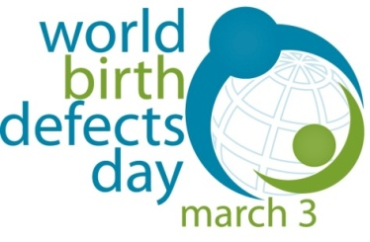
Application Form to be recognized as:
“Participating Organization of World Birth Defects Day”
Please send the request via email as soon as possible and not later than February 10, 2017
to centre@icbdsr.org“ Subject: Application as WBDD Participating Organization”

- The organization requesting to be designated as “Participating Organizationof World Birth Defects Day” to promote the World Birth Defects Day (WBDD):
Name_________________________________________________ Country/region________________________
Please, use the full official name
Please attach the logo of your organization as a .jpg file. It will be published on global WBDD announcements (in case of acceptance of the application)

- Is the organization a for-profit institution (No – Yes) ____ If yes, please explain ________________

- Who will serve as the organization’s liaison for WBDD?
Name and title: ______________________________________________ email:___________________________

- Mandatory: Web Presence (e.g.,Website, Facebook account/page, Twitter account) of the organization (please specify URL) ____________________________________ ____________________________________
______________________________________________ ____________________________________

- Optional: Personal accounts of leading persons of the organization to create a global network on social media (please specify URL) _____________________________ __________________________________
_________________________________________ _________________________________________

- Mandatory: in order to observe the WBDD, as all the other organizations promoting the WBDD, we will:
- Inform our associates about WBDD and encourage them to promote WBDD
- Post an announcement with the WBDD logo (please see attcahed) on our Web Presence
- Promote WBDD via social media, particularly through Twitter
Further information on how to join the social media activity will be provided at later time

- Optional: We will also organize local activities: (No – Yes) ___________
If yes, please specify (see examples in Appendix 1 on next page) and send detailed Information at later time to be included in the report of global activities: ________________________________________________
__________________________________________________________________________________________

We understand that we will be informed about the acceptance of our application status within two weeks from the submission date. If accepted, our organization’s name and logo will be listed on WBDD announcements, alongside names and logos of the other Participating Organizations (www.icbdsr.org).

Full Name_____________________________________ Date:____________________________

Please, try to build with all your contacts a real node of organizations participating in the WBDD, and please transmit to them the need to enhance the network and make it really powerful. Just tell them to contact centre@icdsr.org for this purpose, or disseminate this form among them.

Appendix 1.
Selected examples of activities that can be performed on March 3 or in the days around March 3:
- Scientific Conference
- Face-to-face training course for professionals
- Online course for professionals
- Educational meeting for the general public
- Press conference
- Articles on birth defects on magazines or newspapers
- News story, featuring a family’s story or other topic
- One or more videos on YouTube on any birth defects topic for professionals, in any language
- One or more videos on YouTube on any birth defects topic for general public, in any language
- One or more days of an “Open Telephone Consultation” on any topic related to birth defects
- Any community-based activity (e.g., marathon, sports competition) promoting WBDD

