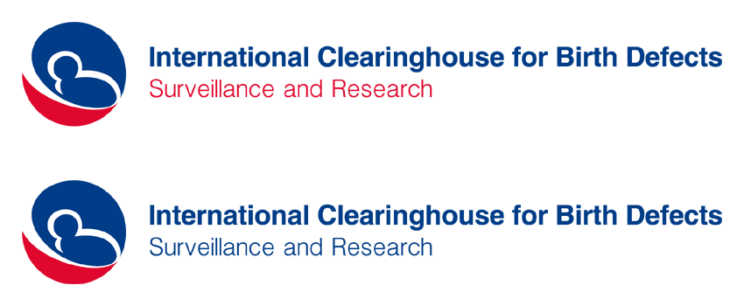44th Annual Meeting – November 13-15, 2017
Sheraton Austin Hotel at the Capitol, Austin, Texas, U.S.
Registration Form

Please use block letters and return it to centre@icbdsr.org by 10 October 2017
Hotel Reservations by the Star Groups customized website: https://www.starwoodmeeting.com/Book/ICBDSRAnnualMeeting, or by the Group Reservation Center at
+1-888-627-8349 by 5:00 p.m. local time on 13 October 2017.
Room block is from 12th to 15th November. Additional nights can be booked by emailing Anthony Gemenes: agemenes@sheratonaustinhotel.com, subject line “Additional night request ICBDSR”

First name: ……...................................….…………… Last name.........................................................................
Institution: .....................................................................................................................................................
Phone: …................................................…...... E-mail: ..................................................................................
Arrival date ....................................………….… Time........................................... Flight #................................
Departure date............................................ Time.......................................... Flight #................................
If you don’t know yet your flight details, please provide at least arrival and departure dates

Please, confirm your participation in the Scientific Program (see attached Meeting’s Program):
- November 13 (Mon) – Lectures and Scientific Sessions [ ] YES [ ] NO
- November 14, morning (Tue)– ICBDSR Business Meeting (ICBDSR members only) [ ] YES [ ] NO
If yes, in representation of the ICBDSR member program...............................................................................
or as second representative of the ICBDSR member program.........................................................................
or as Affiliate member (without voting right)..................................................................................................
- November 14, afternoon (Tue) – Scientific Sessions [ ] YES [ ] NO
- November 15, morning (Wed) Scientific Session on Zika [ ] YES [ ] NO
- November 15, afternoon (Wed) – Lecture and Collaborative Projects’ Session [ ] YES [ ] NO

Please, confirm you will register for:
- Full meeting-3 days: 13-14-15 November (3 lunches, 5 coffee-breaks, syllabus) US$ 310.00 [ ]
- Partial meeting-2 days: 13-14 November (2 lunches and 4 coffee-breaks, syllabus) US$ 230.00
- Partial meeting – 1 day: 15 November (1 lunch and 1 coffee-break, syllabus) US$ 80.00 [ ]
Registration fee to be paid in cash (US dollars) at registration desk or by wire transfer into the ICBDSR bank account, before the meeting – See bank details in the next page

Please, confirm your participation in the Social Events:
- November 12 (Sun): Welcome reception (offered by ICBDSR) ¹ [ ] YES [ ] NO
If yes, with accompanying person: [ ] YES [ ] NO
- November 15, afternoon/evening Cruise by Lone Star
Riverboat and dinner onboard (personal pay)² [ ] YES [ ] NO
If yes, with accompanying person: [ ] YES [ ] NO
If you would like, bring a bottle of your favourite wine from your country, to share with the group during the dinner on the Lone Star
¹ Welcome cocktail at Sheraton Austin Hotel at the Capitol, on Sunday 12 November, at 7:30 pm – open to ICBDSR members, abstracts presenters, invited speakers, and accompanying persons
² The tour includes transportation from Hotel to Lone Star’s dock, a delightful cruise right through the heart of downtown Austin, dinner onboard by Trudy’s Restaurant. Estimated cost: US$ 65 per person (30 attendees minimum, cost may increase if less than 30).
Tour schedule:
4:15 pm: departure from the hotel
4:45 pm: arrival to Lone Star Riverboat
4:45–5:00 pm: passengers’ boarding
5:15 – 7:15 pm: sunset cruise and dinner onboard by Trudy’s Restaurant (2 entrees, 3 sides, desserts + tea, water, ice)

Bank information for performing Wire payments:

Beneficiary-------------------- ICBDSR
Beneficiary address: ------- Via Carlo Mirabello 14 – 00195 Rome, Italy
Beneficiary's Bank---------- CDC Federal Credit Union
Bank's address-------------- 2301 ParkLake Drive NE, 30345 Atlanta, GA, USA
Bank Account No---------- 215590
Sort code or swift code--- US084000026196113
ABA No/CHIPS-------------- 261171244
Please, mention “AM 2017 registration fee + name(s)” of the person(s) to be registered.

Please let ICBDSR Centre know (centre@icbdsr.org) when the transfer is arranged, so we can record and acknowledge the transaction. You will receive an email from Simonetta Zezza acknowledging that you have paid your registration fee. If you do not receive an acknowledgement, it means your payment has not been deposited (we will only acknowledge payment once the wire transfer has been cleared by the bank).
ICBDSR will issue a receipt for the registration fee, upon request.

Thank you!

