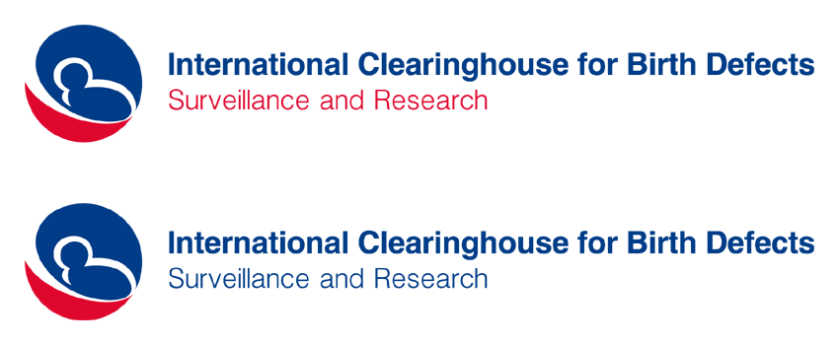45th Annual Meeting – September 30 – October 3, 2018
Hotel Olšanka, Prague, Czech Republic
Registration Form
Please use block letters and return it to centre@icbdsr.org by August 31, 2018
Bunch of Rooms will be reserved at Hotel Olšanka for the participants of the meeting.
Reservations shall be done by email to rezervace@hotelolsanka.cz mentioning the “ICBDSR” password. No cancellation fee will be charged in case of cancellation of those reservation. Reservation shall be made before May 30th 2018!

First name: ……...................................….…………… Last name.........................................................................
Institution: .....................................................................................................................................................
Phone: …................................................…...... E-mail: ..................................................................................
Arrival date ....................................………….… Departure date............................................

Please, confirm your participation in the Scientific Program (see attached Meeting’s Program):
- September 30, afternoon (Sun) – World Birth Defects Day Meeting [ ] YES [ ] NO
- October 1 (Mon) – Lectures and Scientific Sessions [ ] YES [ ] NO
- October 2, morning (Tue)– ICBDSR Business Meeting (ICBDSR members only) [ ] YES [ ] NO
If yes, in representation of the ICBDSR member program...............................................................................
or as second representative of the ICBDSR member program.........................................................................
or as Affiliate member (without voting right)..................................................................................................
- October 2, afternoon (Tue) – Scientific Sessions [ ] YES [ ] NO
- October 3 (Wed) Scientific Session on Rare Defects [ ] YES [ ] NO

Registration fee
Full meeting (3 days from Mon to Wed): €160.00 (around US$ 200.00)
Registration fee includes the meeting Syllabus, lunches and coffee-breaks from Monday Oct 1st to Wednesday Oct 3rd, and the dinner at Hotel Olšanka on Monday, Oct 1st.

Please, confirm your participation in the Social Events:
- September 30 (Sun): Welcome reception (offered by ICBDSR) ¹ [ ] YES [ ] NO
If yes, with accompanying person: [ ] YES [ ] NO
If you would like, bring a bottle of your favourite wine from your country, to share with the group

- October 1 (Mon): Dinner Hotel Olšanka (incl in the registration fee) [ ] YES [ ] NO
If yes, with accompanying person (personal pay): [ ] YES [ ] NO

- October 2 (Tue): Dinner at Municipal House²(personal pay)² [ ] YES [ ] NO
If yes, with accompanying person: [ ] YES [ ] NO

- October 4 (Thu): Tour to Kutná Hora (personal pay)³ [ ] YES [ ] NO
If yes, with accompanying person: [ ] YES [ ] NO
¹ Welcome cocktail at Olšanka Hotel on Sunday 30 September, at 7:30 pm – open to all registered participants, ICBDSR members, abstracts presenters, invited speakers, and accompanying persons
² The dinner includes a small trip by a tram rented from the Prague Public Transit Co (around 1 hr) and the dinner in the Municipal House. Estimated cost will be provided at a later time.
³ Tour at historical medieval mining city of Kutna Hora https://en.wikipedia.org/wiki/Kutn%C3%A1_Hora – whole day, including lunch and coach transport. Estimated cost will be provided at a later time

